Roskassa for CMS osCommerce v2

Unpack the rk_oscommerce_version_2.zip archive in the root of the site
Go to the admin panel and go to the "Modules -> Payment" section.
And click on the “Install Module” button
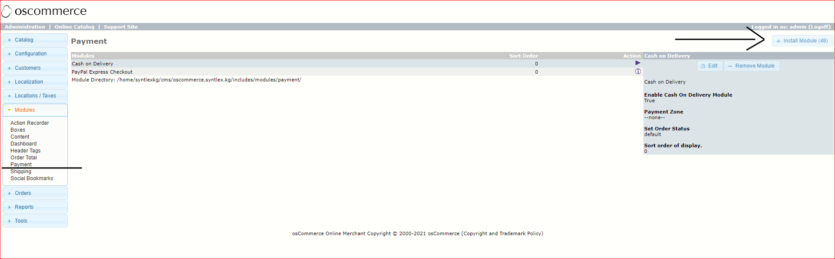

In the page that opens, find and select “Roskassa”, then click on the “Install Module” button
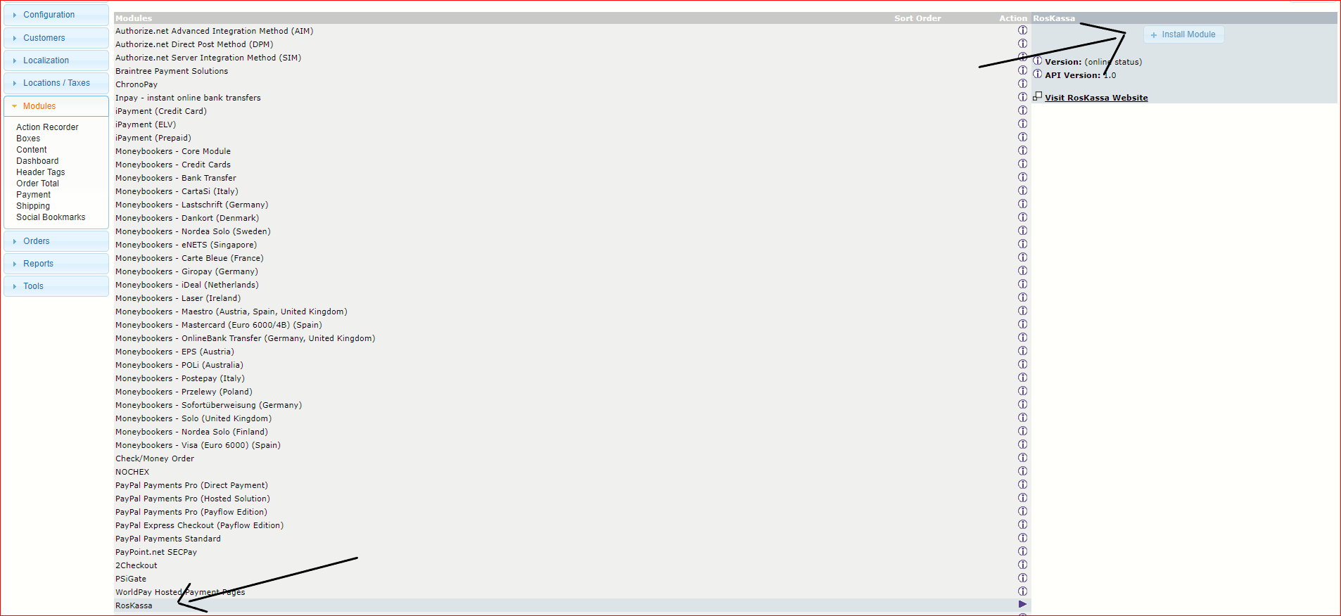
After installing the module, enter the parameters of the Roskassa system in the settings, for this select the payment module “Roskassa” from the list
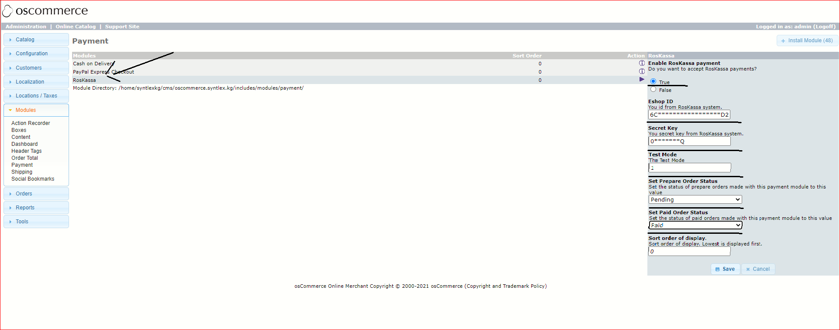

Be sure to fill in the fields:
Eshop ID — id of your store in the system https://roskassa.net (you can find out in your personal account)
Secret Key – your store's secret key
Test Mode – enter 1 or 0 (1 - activates test mode and 0 - deactivates)
Click “Save” to save the settings.
Then, enter the URLs in your “Roskassa account → Settings”.

Successful payment URL
No need to enter
Unsuccessful payment URL
No need to enter
Handler URL
https://********** /ext/modules/payment/roskassa/callback.php
Where ***** - is your domain

Click “Apply Changes”.
Roskassa module for CMS osCommerce v2 is configured.

